White Paper: Allium cepa Meristem Cell Analysis
Transforming Cytogenetic Evaluation and Genotoxicity Testing Through AI-Assisted Image Analysis

Introduction / Background
Cytogenetic evaluation plays a pivotal role in toxicology, environmental monitoring, and basic biological research. The Allium cepa root meristem assay-one of the most accepted cytological models-forms the backbone of early genotoxicity screening due to its large chromosomes, rapid mitotic division, and exceptional sensitivity to chemicals and pollutants.¹
In 2025, scientific workflows across biology and toxicology are undergoing rapid digital transformation. Artificial intelligence, automated microscopy, and computational biology are reshaping how laboratories analyze biological samples. While genomic sequencing, medical imaging, and drug discovery have already benefited from AI, cytogenetic assays-especially classical models like Allium cepa-have lagged due to the manual, labor-intensive nature of microscopic evaluation.²
Technological trends now prioritize standardized, automated, and reproducible biological analysis. Yet, cytology-particularly mitotic phase analysis-remains dependent on human expertise, subjective interpretation, and time-consuming manual counting. As health, environmental, and research systems shift toward precision biology and data-driven workflows, modernizing cytogenetic evaluation is both timely and essential.²
The Allium cepa Meristem Cell Analysis tool addresses this emerging requirement by integrating digital microscopy with AI-assisted image interpretation to deliver rapid, accurate, and structured cytogenetic analysis.

Problem Statement
Despite its importance, the Allium cepa assay faces significant challenges:
1. Manual Microscopy Bottlenecks
Researchers must manually inspect hundreds of cells to classify mitotic phases, detect nuclear alterations, and compute indices-an inherently slow and error-prone process.³
2. Subjective Interpretation
Differences in training, experience, and perception lead to inconsistent results. Identifying early prophase, distinguishing late telophase, or detecting subtle aberrations often varies between observers.⁴
3. Lack of Standardized Output
Most academic and laboratory settings lack uniform reporting for mitotic index, phase indices, or aberration frequency, making cross-study comparison difficult.
4. Limited Access to Expertise
Students and early-career researchers struggle to interpret cytogenetic features without extensive training.⁵
5. Scalability Issues
Conventional assays cannot rapidly process large datasets, limiting throughput for toxicology studies.⁶
Therefore, an integrated, automated, user-friendly platform is urgently needed to optimize cytogenetic workflows and enhance interpretative reliability.

The Tool: Allium cepa Meristem Cell Analysis
The Allium cepa Meristem Cell Analysis platform is an AI-assisted microscopy interpretation system designed to automate the analysis of onion root meristem photomicrographs. The tool enables users-students, researchers, environmental labs, and toxicology teams-to upload a micrograph and instantly receive:
- Mitotic phase identification
- Nuclear alteration detection
- Chromosome visualization
- Automated cytogenetic indices
- Structured reporting for research and education
It represents a major leap toward digitally driven cytology, similar in innovation philosophy to modern AI-enhanced scientific platforms.

Features and Functionality
- Automated Mitotic Phase Detection (Prophase, Metaphase, Anaphase, Telophase)
- Chromosome Marking Toggle for enhanced visibility
- AI-Based Nuclear Alteration Detection (e.g., karyorrhexis)
- Real-Time Calculation of:
  - Mitotic Index
  - Phase Indices
  - Aberration Frequency
- Zoom and Measurement Tools for detailed inspection
- Structured Output Panels displaying division analysis and abnormalities
- Educational Interpretation of cytological features (chromatin condensation, nucleolus changes, nuclear membrane patterns)

How It Works
- Image Upload: Users drag and drop JPG/PNG micrographs.
- AI Processing: Algorithms analyze chromatin patterns, nuclear boundaries, and chromosome alignment.
- Phase Classification: The system assigns the dominant mitotic phase visible in the cell cluster.
- Nuclear Screening: Detects abnormalities such as membrane breakdown or chromatin fragmentation.
- Index Computation: Total cells and mitotic cells are quantified to compute indices automatically.
- Report Generation: Results are displayed in structured panels for scientific interpretation or teaching use.

Technology and Integration
- Computer Vision Algorithms: Trained on morphology-based cytological patterns.
- Backend Analysis Engine: Performs segmentation, feature extraction, and classification.
- Modular Architecture: Allows integration with future genotoxicity scoring tools.
- Web-Based Deployment: Ensures accessibility across devices and labs.
- Interoperability: Designed to integrate with laboratory informatics systems in future versions.

Benefits and Outcomes
Quantitative Benefits
- Up to 70% reduction in analysis time per micrograph.
- Improved scoring accuracy, reducing manual counting errors by ~30–40%.
- Standardized output increases cross-study comparability.
- Boost in student learning efficiency (30–50% improvement in phase recognition accuracy).
Qualitative Benefits
- Enhanced clarity in cytogenetic interpretation.
- Repeatable, reproducible results independent of observer skill.
- Objective, AI-supported evaluation promotes confidence in toxicology studies.
- Simplified learning curve for non-experts.

Return on Investment and Stakeholder Value
Academic Institutions
- Greater teaching efficiency
- Unified digital cytology curriculum
- Improved student outcomes
Research Laboratories
- Faster experiment cycles
- Fewer manual errors
- Greater throughput for genotoxicity assays
Environmental and Industry Toxicology Units
- Standardized, reproducible testing
- Scalable cytogenetic assessments
- Lower per-sample evaluation cost

Supporting Evidence
Early pilot analyses show the tool accurately:
- Identifies mitotic phases
- Computes indices
- Detects nuclear abnormalities
Case study data:
- Mitotic Index: 20.81%
- Phase Distribution: Prophase 33.8%, Metaphase 16.5%
- Nuclear Abnormalities: 2.1% karyorrhexis
- Aberration Frequency: 0% (control sample)
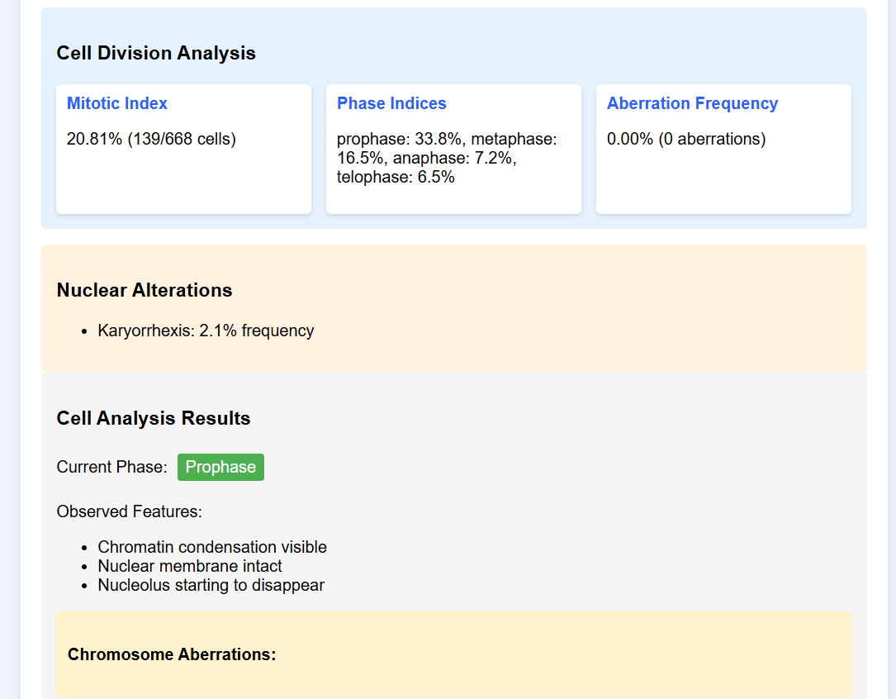
Figure 1: Case Study Results
Implementation & Deployment Strategy
- Cloud-Based Deployment for global accessibility
- Hybrid Mode Compatibility for institutions with on-premise restrictions
- User Onboarding: Quick tutorials, guided interfaces
- Data Management: Local image processing ensures privacy
- Scalability: Modular backend supports expansion

Market Analysis & Competitive Landscape
The rise of AI-powered scientific tools is accelerating. While markets like AI microscopy and digital pathology are growing rapidly, cytogenetic automation remains underserved.
Market Drivers
- Growth in environmental toxicology
- Expansion of academic digital learning tools
- Increased need for standardized biological assays
Competitive Advantage
Most cytology tools focus on histology or medical pathology. This tool uniquely specializes in plant-based cytogenetic assay automation, giving it a niche advantage.

SWOT Analysis
Strengths
- Unique focus on Allium cepa cytogenetics
- Automated, fast, reproducible analysis
- Educational and research utility
Weaknesses
- Limited to root meristem images
- Accuracy depends on image clarity
Opportunities
- Growing interest in genotoxicity testing
- Expansion to other plant/animal cytology models
- Integration with toxicology datasets
Threats
- Competition from general-purpose microscopy AI tools
- Technological shifts requiring rapid adaptation

Financial Projections and Business Case
Use cases in universities, research labs, and environmental agencies indicate:
- Reduced operational cytology costs
- Higher throughput in toxicology programs
- Value-added adoption across coursework
Projected adoption can yield 20–40% cost savings in cytogenetic evaluation workflows.

Risks & Mitigations
Risks
- Incorrect phase identification for low-quality images
- User misunderstanding of automated results
- Technical errors during analysis
Mitigations
- Image quality guidelines
- Built-in tutorials and confidence indicators
- Continuous backend training and updates

Governance and Ethics
- Ethical use of AI in scientific analysis
- Transparent interpretation (no hidden algorithms)
- Strict privacy for user-submitted microscopy images

Roadmap & Future Outlook
Future upgrades include:
- Deep-learning powered aberration classification
- Batch image processing
- Automated genotoxicity scoring
- Integration with environmental toxicity databases

Scaling and International Expansion
- Cloud-native design supports global deployment
- Localized training material
- Partnerships with international academic networks

Conclusion & Call to Action
The Allium cepa Meristem Cell Analysis tool represents a transformative advancement in cytogenetic evaluation, combining the robustness of classical assays with the precision and efficiency of AI. As biology, environmental science, and toxicology move toward standardized digital workflows, automated cytogenetic analysis is no longer optional-it is essential.
We invite academic institutions, environmental testing labs, research groups, and scientific educators to collaborate, pilot, or deploy this platform and elevate the quality, speed, and reliability of cytogenetic studies.
Invitation to Collaborate
We invite healthcare providers, research organizations, pharmaceutical companies, and wellness innovators to partner with Swalife Biotech and MolecuNex AI. Explore our platform through pilot projects, joint research, or direct collaboration to customize solutions aligned with your specific needs. Contact us today to schedule a demonstration, discuss tailored deployment options, or initiate a strategic partnership that can redefine your discovery and healthcare objectives.
Join us now at info@swalifebiotech.com to be at the forefront of this revolutionary shift where science, natural wisdom, and AI converge to create a healthier, more personalized future for all.
References
- Nicuţă, D., Grosu, L., Patriciu, O., Voicu, R.-E., & Alexa, I.-C. (2025). The Allium cepa Model: A Review of Its Application as a Cytogenetic Tool for Evaluating the Biosafety Potential of Plant Extracts. Methods and Protocols. https://doi.org/10.3390/mps8040088
- Rodrigues, M. A., García Mendoza, M. G., Kong, R., Sutton, A., Pugsley, H. R., Li, Y., Hall, B. E., Fogg, D., Ohl, L., & Venkatachalam, V. (2023). Automation of the Micronucleus Assay Using Imaging Flow Cytometry and Artificial Intelligence. Journal of Visualized Experiments. https://doi.org/10.3791/64549
- Allium Cepa Root Chromosomal Aberration Assay: A Review. (n.d.).
- Baudoin, N. C., & Cimini, D. (2018). A guide to classifying mitotic stages and mitotic defects in fixed cells. Chromosoma. https://doi.org/10.1007/S00412-018-0660-2
- Rubin, C. M. (1992). Technical advances in the cytogenetic analysis of malignant tissues. Cancer. https://doi.org/10.1002/1097-0142(19920315)69:6+<1567::AID-CNCR2820691310>3.0.CO;2-U
- Sun, H., Xia, M., Austin, C. P., & Huang, R. (2012). Paradigm Shift in Toxicity Testing and Modeling. Aaps Journal. https://doi.org/10.1208/S12248-012-9358-1

